Mount Falaza Trail Ultra
Marathon of Primorye Taiga
Date: 14 of October
Location: Gribanovka ski resort, Primorye, Russia
120 km far from Vladivostok city – capital of Primorye
Trailrunning competition will be held on the 16th of October. Start and finish is on the well-known ski resort “Gribanovka”.
Distances:
11 км 943 D+
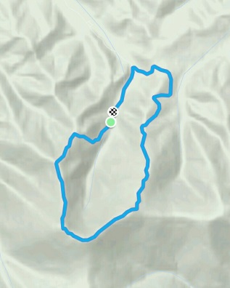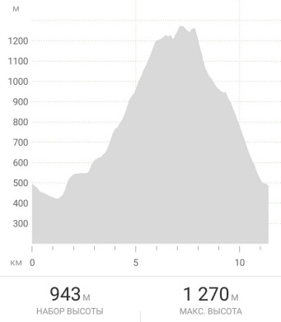
One of the most popular trails among tourists and amateurs. Run for yourself, run for pleasure! Try what “trailrunning” is when you run up and down on trails. Test yourself in the company with your friends and close people, enjoy beautiful golden forest and mild season in Primorye.

39 км 1522 D+
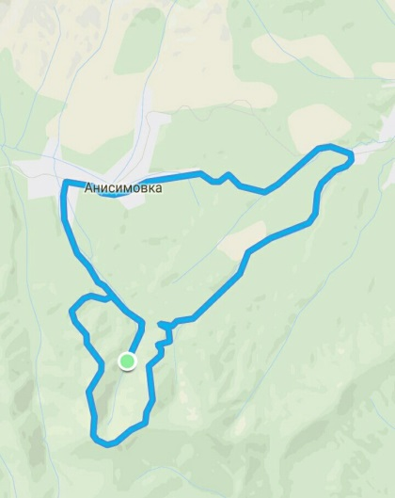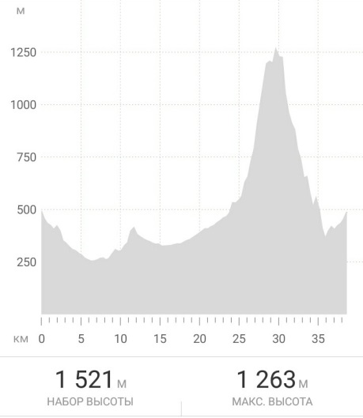
This distance is for serious sportsmen. Several hours of intense work will be paid off. You meet different landscapes: from gravel roads to narrow trails in the woods, from moon landscapes full of stones to thick bushes of microbiota decussate – endemic of Sikhote-Alin Mountains you can meet 1300 m high above sea level.

50 км 1834 D+
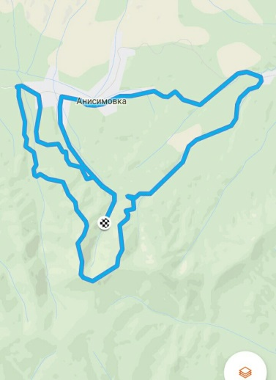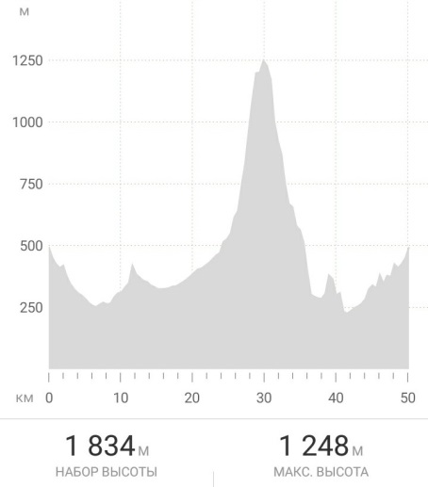
That is really serious test! Just get ready and train hard! That what we call “Ultra” - trail starting from 50 km. You can get into another reality and change your consciousness on such a long distance. Like Dean Karnazes (American Ultramarathon runner) says:
“If you want to run, run a mile. If you want to experience a different life, run a marathon. If you want to talk to God, run an ultra.”
We are glad to announce that Mount Falaza Trail Ultra is on the calendar of AsiaTrailMaster series. Winners will get scores for their rank and additional bonuses for participating in other races abroad. Full calendar and more detailed information you can see on the link:
www.asiatrailmaster.com

Mt. Falaza Trail Program:
12 - 13 October 2017:
Participants arrive to Vladivostok city – capital of Primorye.
13 October:
10:00 - transfer to Gribanovka ski resort (120 km from Vladivostok city)
16:00 – race briefing
17:00 – 19:00 - registration
14 October 2017:
8:00 – start 39 km and 50 km distances
11:00 – start 11 km distance
Cut-off time (time limit): 11 km – 3:30
39 km – 6:30
50 km – 8:00
17:00 – all the distances close
18:00 – prize-giving ceremony
Notice! For more detailed information follow:
www.gribanowka.ru
https://vk.com/club104400792
https://vk.com/club99034128
Contact person: Alexey Chakhlov. Tel. +7 924 1380446
E-mail: chakhlov_ride@mail.ru

